Meeting Agenda

Meeting | District Educational Improvement Committee
Date | December 13, 2023
Time | 4:30 PM – 5:45 PM
Location | MISD Professional Development Room
Participants | Parents, Community Members, and Staff
Purpose | Communication, Input, and Planning
Facilitators | Dr. Edie Martin, Superintendent  Dale Latham, Assistant Superintendent

Agenda Topic | Facilitator
Welcome | E. Martin
Introductions
Mission/Vision/Values – A PREMIER vision
Superintendent’s Report - Facilities
DEIC Training, Including District Goals | D. Latham
District Improvement Plan on a Page
Policy Update EIC (LOCAL)
School Calendar 2024-2025 | E. Martin
Future Meetings (January - days of week/time)
Closing / Evaluation

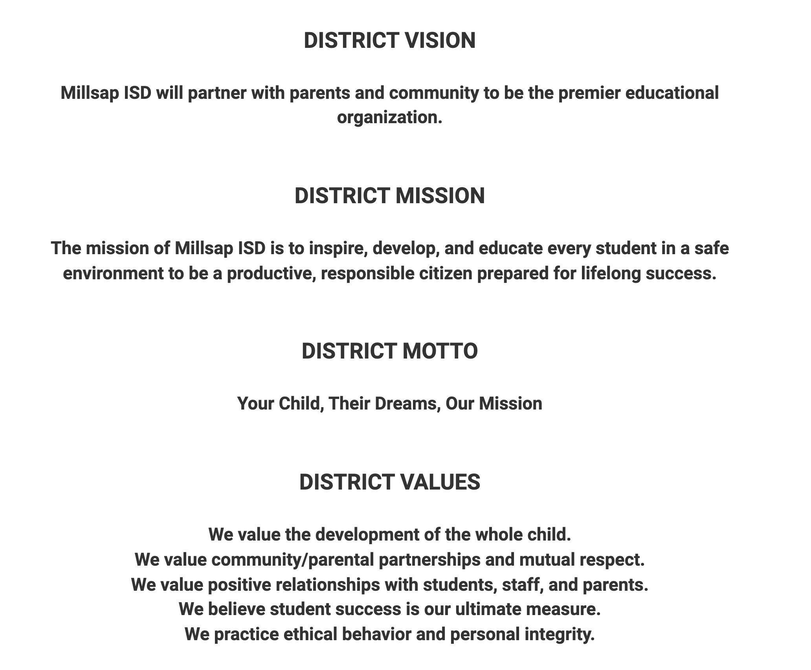

DEIC Meeting
December 11, 2023

- Welcome: Dr. Martin brought the welcome and shared about Millsap ISD’s mission, vision, and values.
- Introductions: Participants each introduced themselves.
- Superintendent Report: The Superintendent’s Report included a Facility update and information was provided about the current facilities and the updates that the district is currently in the process of completing. Highlights included
  - Project #1: Renovations of the Track and installing Turf for the football field
  - Project #2: Adding Capacity at MES through Concept 1 or Concept 2
  - Project #3: Secure Safety Vestibule at MHS
- DEIC Training: Mr. Latham provided a DEIC training concerning the purpose of the DEIC committee and the regulations of how it legally should be implemented. Discussion included federal planning requirements, district performance objectives, comprehensive needs assessment, district goals and strategies, stakeholder input,
- District Improvement Plan Review – The committee reviewed the district improvement plan discussed it goals and components. Discussion included the following:
  - Mental health
  - Special Education
  - Professional Development
  - Continuous Improvement Process
- Strategic Plan Balanced Scorecard Update: The Administrative team are currently working to consolidate all our district initiatives into one set of priorities. The priorities are designed as a district scorecard and will continue to be built to highlight how we will reach our goals through the focus on our priorities.
  - Priority 1: Student Excellence
  - Priority 2: High-Quality Staff
  - Priority 3: Stakeholder Engagement
  - Priority 3: Strong Financial Stewardship and Internal Process Efficiency
- Proposed Policy Update on EIC (Local):
  - The committee reviewed the current policy and then reviewed/discussed the proposed EIC (Local) update.
  - This came up when the MISD Admin team did a Policy Review in the summer of 2023.
  - Starting with 8th graders in 23-24 it is proposed to transition to this new policy.
  - The update is not based on numeric grades but instead a GPA system.
  - Questions were taken here and discussion occurred.
- School Calendar 2024 – 2025:
  - Individuals brainstormed pros and cons of the current calendar.
  - Table groups talked and debriefed the individual ideas
  - Group 1: Overall positive the natural fall of the days off well
  - Group 2: Timing is perfect – to regain our energy and go again, vacations are cheaper during these times
  - Group 3: Positive, teachers and parents, breaks are well planned out.
  - Group 4: Positive overall, refreshing even for volleyball and donuts in the morning, a time to catch up, mental health
  - College courses – nice to have a break and focus on the college course
  - Cons – Lacks of PD days – Can be individual driven, Summer time training Capturing Kids Hearts, focus to find time together

